# Color Me RGB

## Github Link:

<https://github.com/sim2kid/ColorMeRGB>

## About:

Color me RGB is a game where you guess the RGB values of 5 colors. The goal is to get as close as you can to the actual color’s value. This is measured in color ‘distance’ where the shorter your distance, the better your guess is.

## Measuring distance:

To measure the distance between two color values, we map the colors to 3d space. The RGB will be used as XYZ values, then you can apply a euclidian distance formula to get the distance!  
This distance is intended to be short and not tell you in which direction to travel to decrease it. Kind of like the “Hot Cold” game.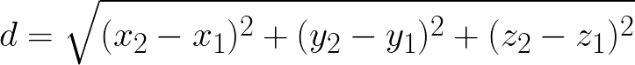

## Game Mechanics:

Upon playing, players will be presented with a colored square. The color of the square will be randomly selected by the computer using RGB values. Players will then have to guess the correct RGB values of the color shown to them. Players have one guess to get it right. Below the original colored square, another square will appear, this time the color that the player guessed so that they can see how close they were to the original color. This will repeat five times, and once players have completed all five guesses their ‘stats’ will be displayed. This will be 10 squares, five the colors players had to guess, and five the players guesses along with their RGB values.

This game is intended to be played once a day. Each day players get five new colors to guess and their daily stats are added to their play record. Players will create an account and log in to play and access their record. The record will be composed of each day's 10 squares (the colors to guess and the players guesses). This way players can look back at previous games and figure out if they are improving.

## Wireframe of Game Appearance:

## Software General Layout:

| Front End:   | MVC - Asp.Net Core | | --- | | Services | | Back End:   | Game Logic | | --- | | Services | | API - Asp.Net Core API | | Unit Tests - XUnit | | Logger | |
| --- | --- | --- | --- | --- | --- | --- | --- | --- |